**A REPORT ON PYTHON PROJECT HERMOSO (beauty service app)**

**Aim**: The main objective behind this project is to design a Business application though which customers get access towards beauty services at their door step.

**Description**: This application enables customers to book different beauty services and for each person a professional is hired to do their job at customers place. This application has five main categories namely Nailart , Mehendi , Hair Cuts, Bridal packages and Beauty spa. Each category has its own list of services and allows the people to select their desired service.

**Tools**: The entire program is written in Python language.

Tkinter,pil

Modules

Functions

Python Interpreter

**Important Concepts Used in the Application:**

Python (3.7.2) programming language is used for implementing the project. Tkinter is the Python interface to the Tk GUI toolkit shipped with Python. It is the standard GUI library for Python .Tkinter only supports GIF,PPM,PGM formats. In order to use images of other formats, Python Imaging Library (PIL) has also been installed and imported. Some of the important concepts used in the implementation of the project are presented in this section:

A)Tkinter widgets:

Tkinter provides various built in widgets. Buttons, Labels, Entry boxes, Textboxes, Check buttons have been used in the project. For new windows, Toplevel () window has been used.

B) Log-in page:

In order to book a beauty service, the user has to log in .For a new user, there is a sign-up option. A file “details.py” has been created containing the details of 10 users. When the user enters the name and password, these are searched in the file and compared with the details retrieved from the file .If both name and password match, then only the user is allowed to proceed. When a new user wants to sign up, his/her newly entered details get appended to the file “details.py”.For log in , the file is opened in read mode. For sign up, the file is opened in append+ mode. In the file, each line contains the details of one person separated by ‘,’. File functions readlines(),readline(),write(),seek() have been used.

C)Home page and slide show:

The home page consists of 5 buttons each representing a main service. The homepage also consists a slide show. ”after()” method has been used to create the slide show. Every widget has an after method that will generate an event at a specific time interval from the time it is called. The method takes at least 2 arguments: the amount of time (in milliseconds) to wait before generating the event, and the call back function to call after the time has elapsed. The sleep( ) function should not be used because the GUI can’t run while the program is asleep. time.sleep() suspends the execution of the program. So, it should not be used. Labels corresponding to 5 images have been kept in a list. Firstly, the first label is displayed .After few seconds, the first label is forgotten using place_forget() method and the second image is placed at the same position on the window. This process is repeated over a loop.

D)Check buttons and bill:

The Check button widget is used to display a number of options to a user as toggle buttons. The user can then select one or more options by clicking the button corresponding to each option. Images also can be used instead of text. Check button was selected over radio button because using radio buttons we can select only one option. For keeping track of the cost of the selected services(check buttons) the concept of variable has been used. variable is a parameter of the check button().It is a control variable that tracks the current state of the check button. Normally this variable is an IntVar, and 0 means cleared and 1 means set. For each check button, the corresponding variable has been set to the cost of the service. The variable sets to the corresponding cost if the button is selected(on value) ,else remains 0(default off value). While calculating the bill, the values of these variables have been used to know which buttons are selected and which are not.

E) End page and display of beautician details:

In the final page, details of the user are asked again. Also the timings and date are taken from the user. These details, along with the major service chosen by the user are appended to a file “new.py” for reference. After this, a beautician is allotted to the user and her details are displayed on the window. All the beautician details are stored in a file “bdetails.py”. Each time a beautician’s details are read from the file and printed on the window.

**Application Flow with Screen Shots**

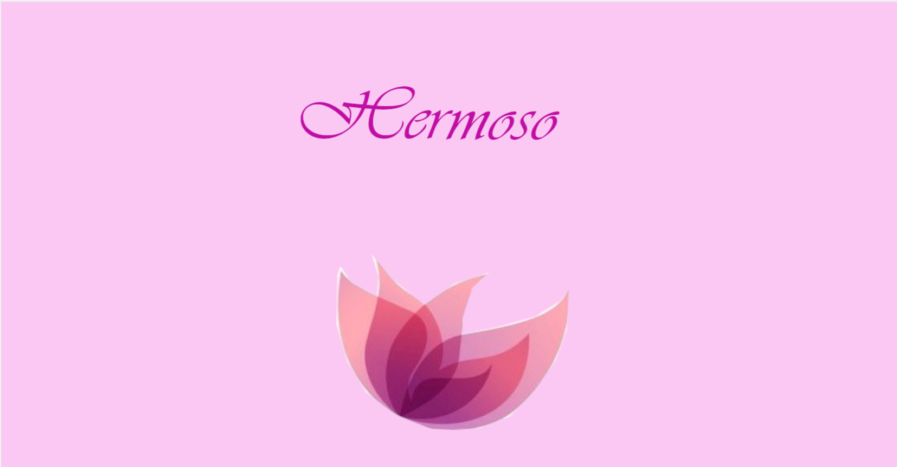

This is the first page that appears when the program is run.

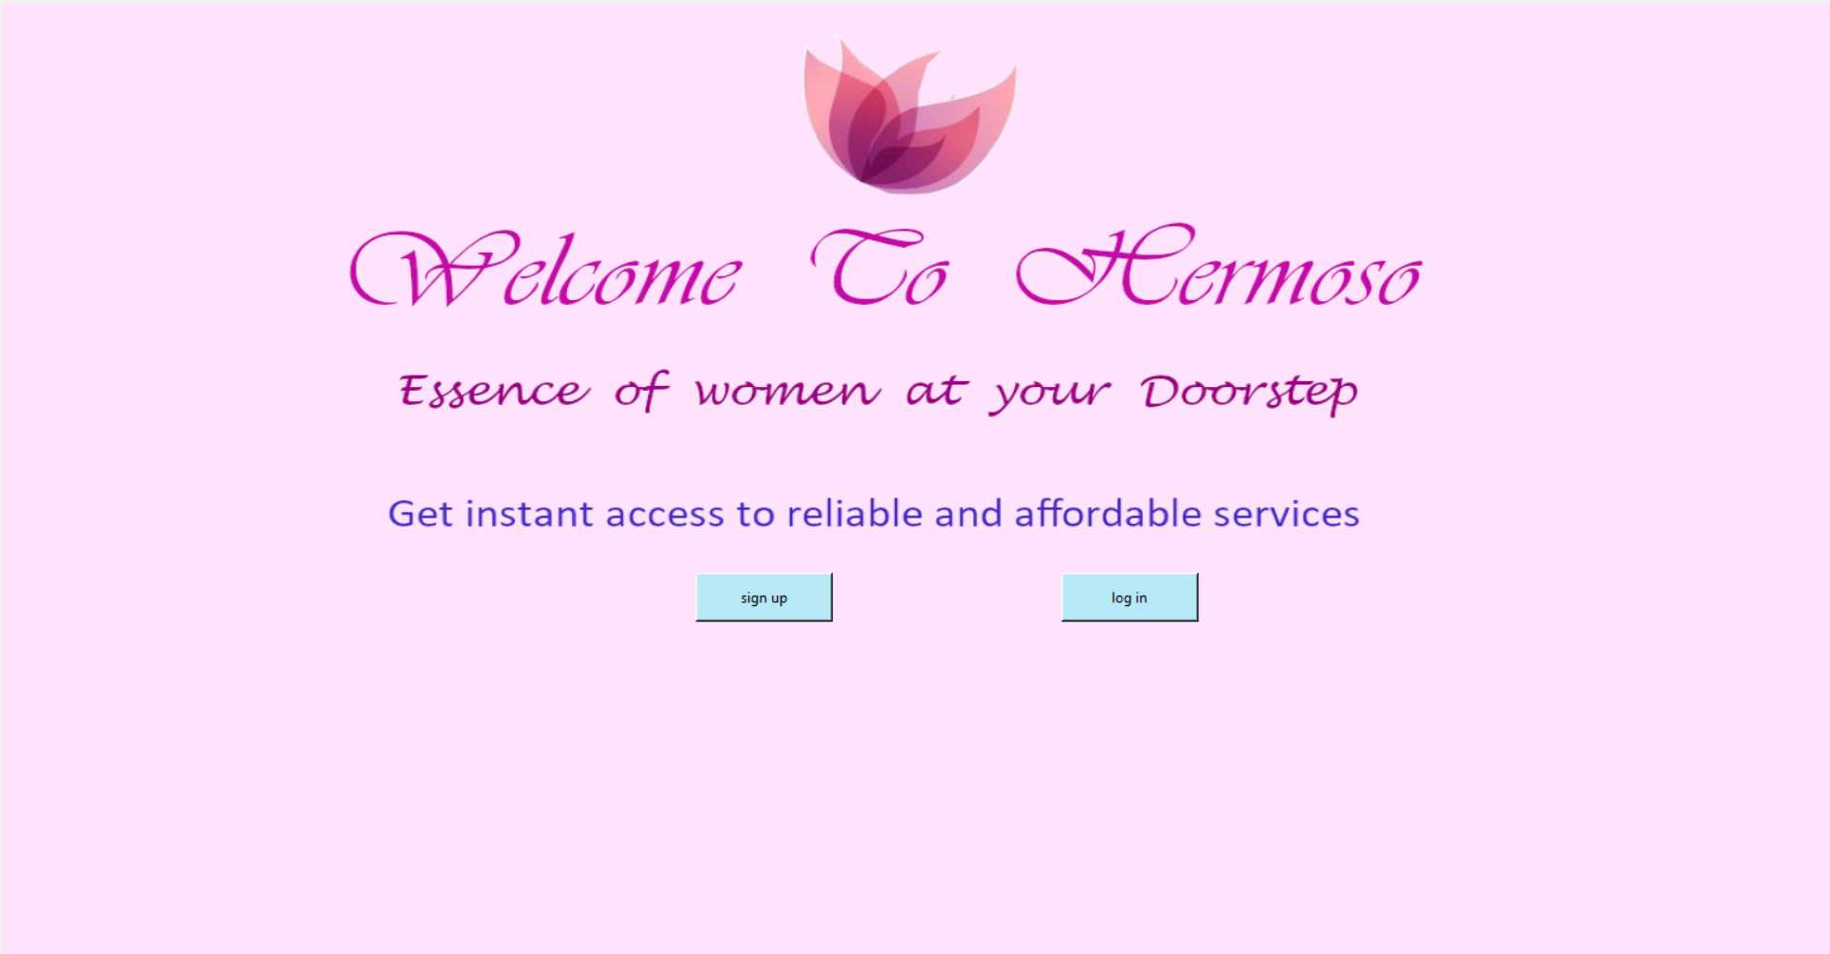

This is the log in page

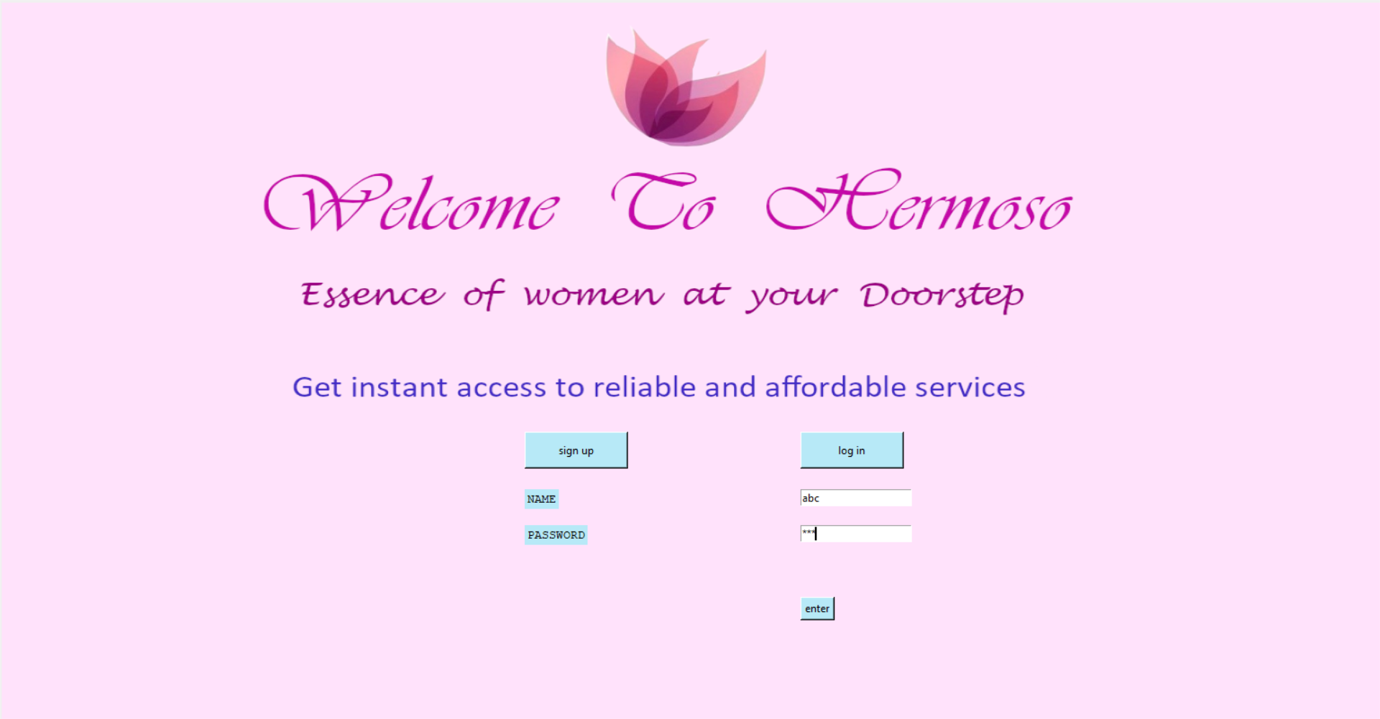

This appears when log in button is clicked

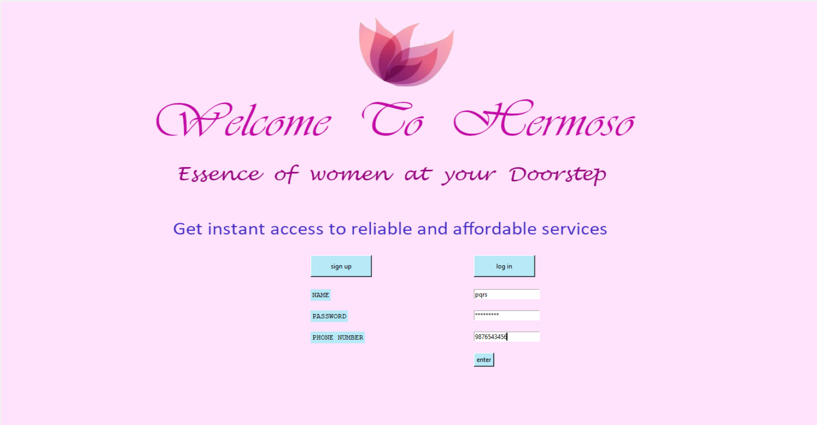

This appears when sign up button is clicked.

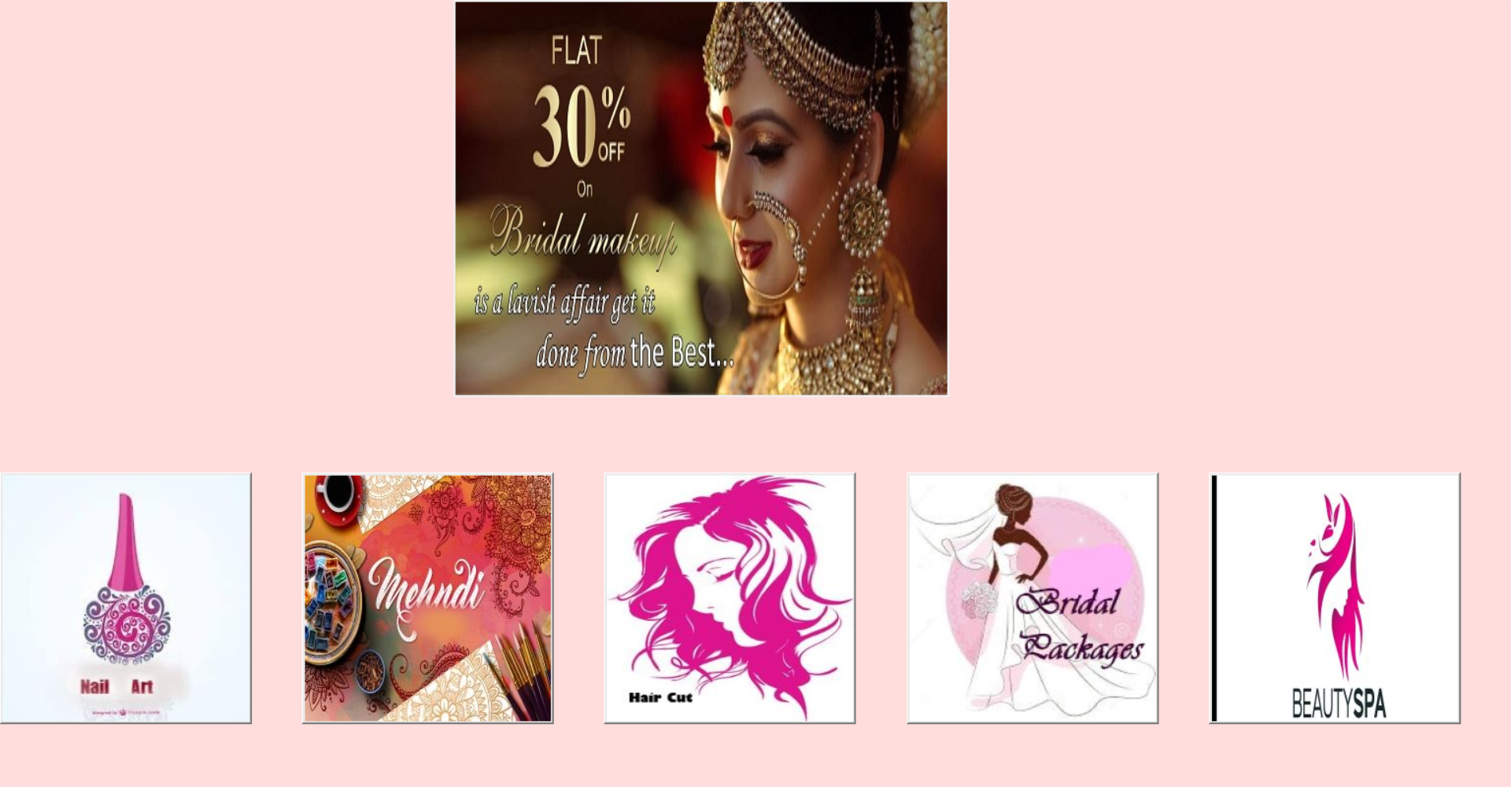

This is the homepage which appears after successful log in. This page consists of a slide show and 5 buttons as shown. The user can choose any service among the following.

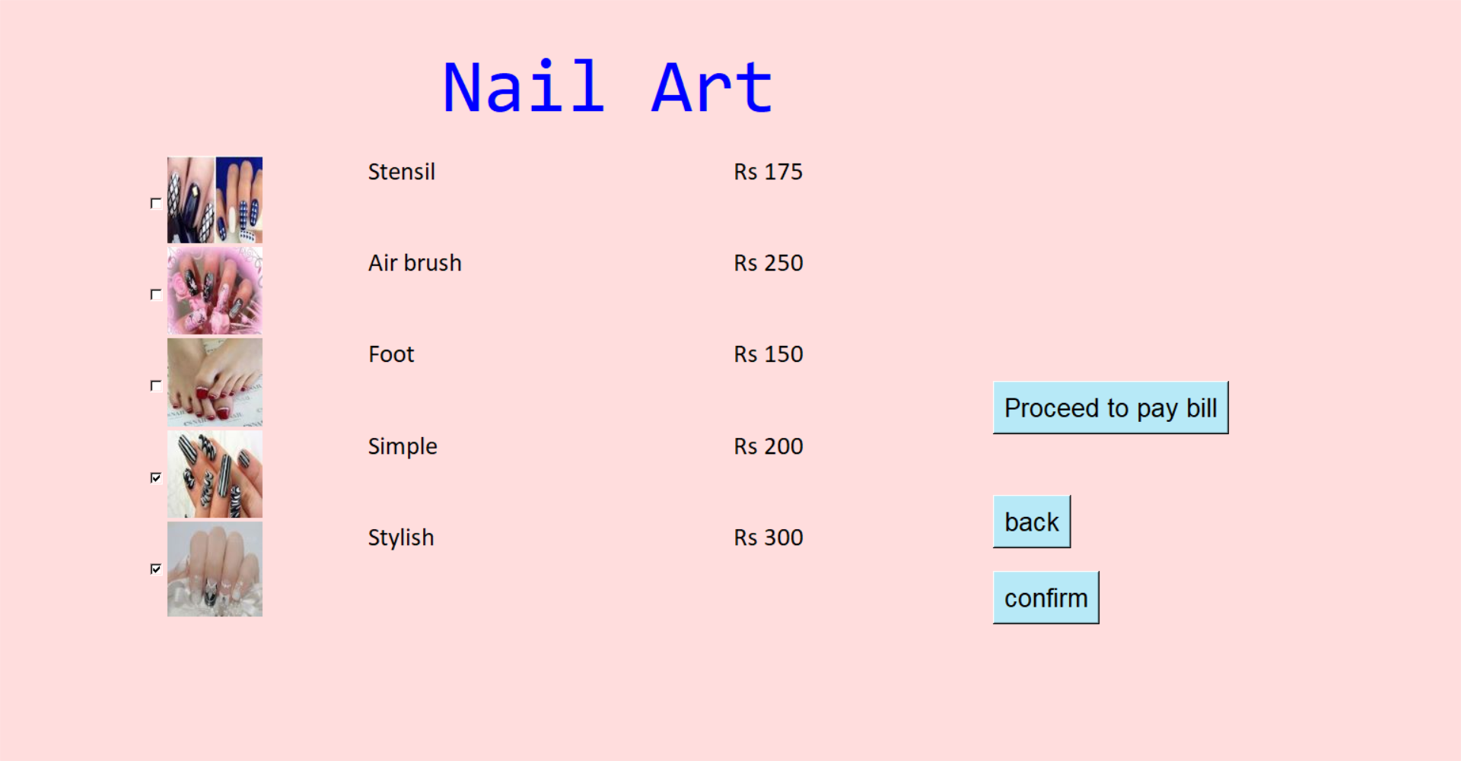

When the first button (nail art) is clicked the above page opens. The user can select any option by clicking on the check buttons. The user must confirm his/her options. After confirming, if the user wishes to choose another category, he/she must select the back button. If not, proceed to pay bill can be selected to pay the bill.

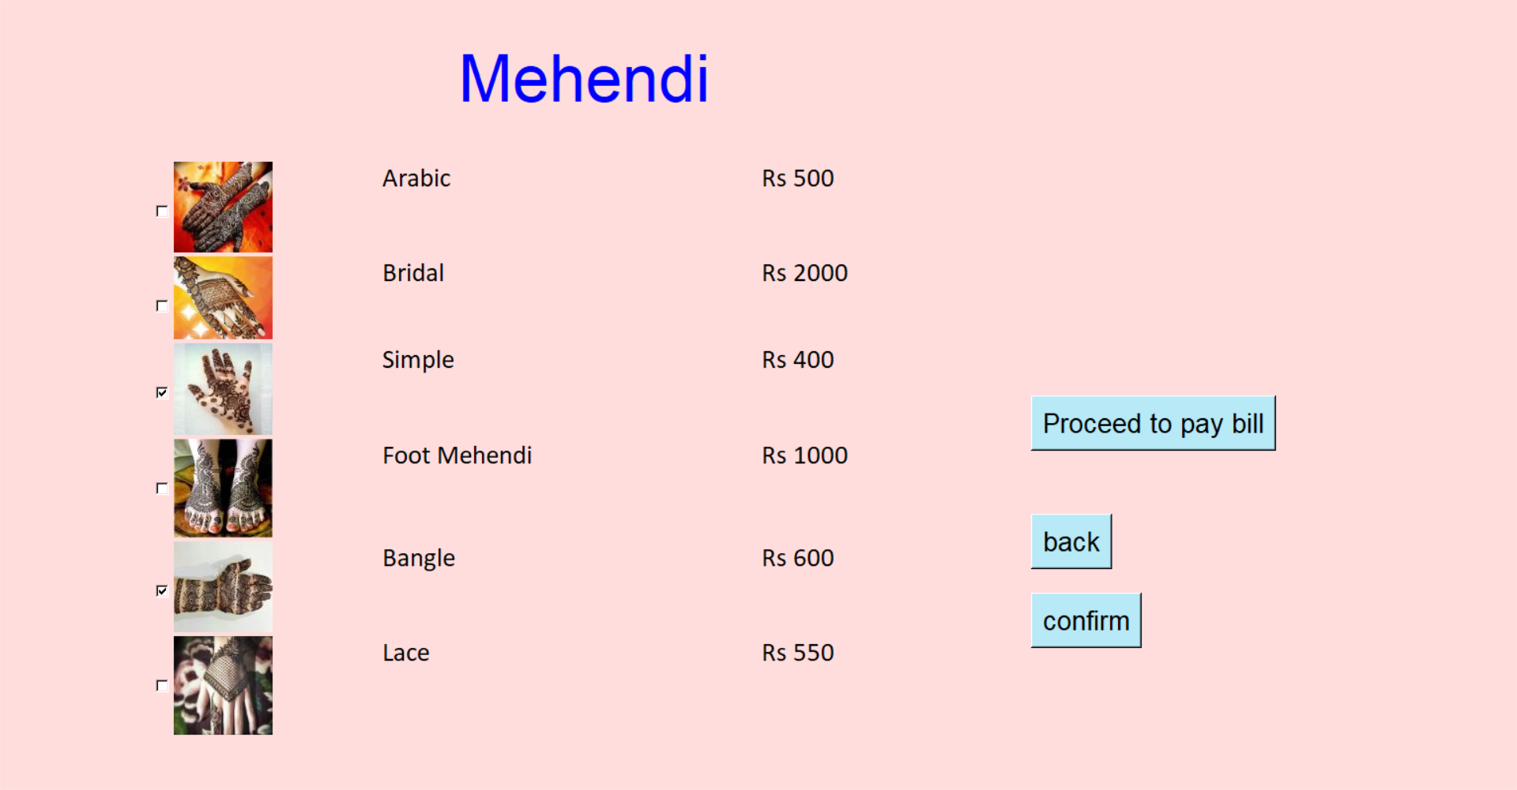

Similarly, when mehendi option is selected in the home page, this page appears.

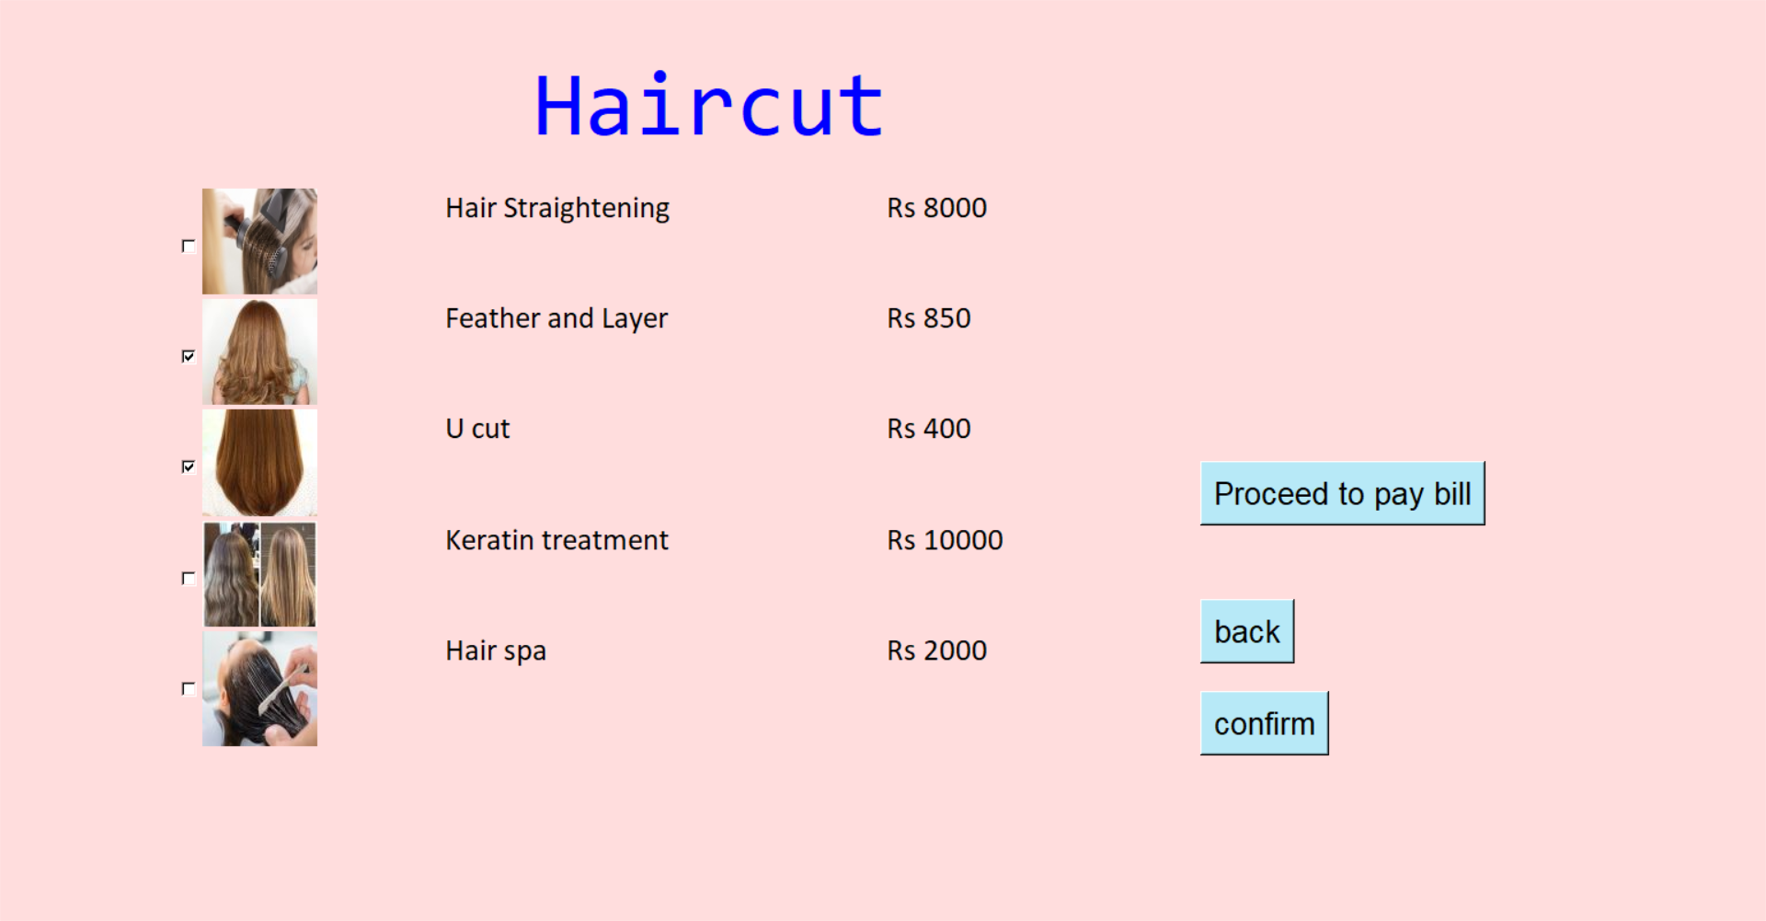

This page appears when haircut option is selected in the home page.

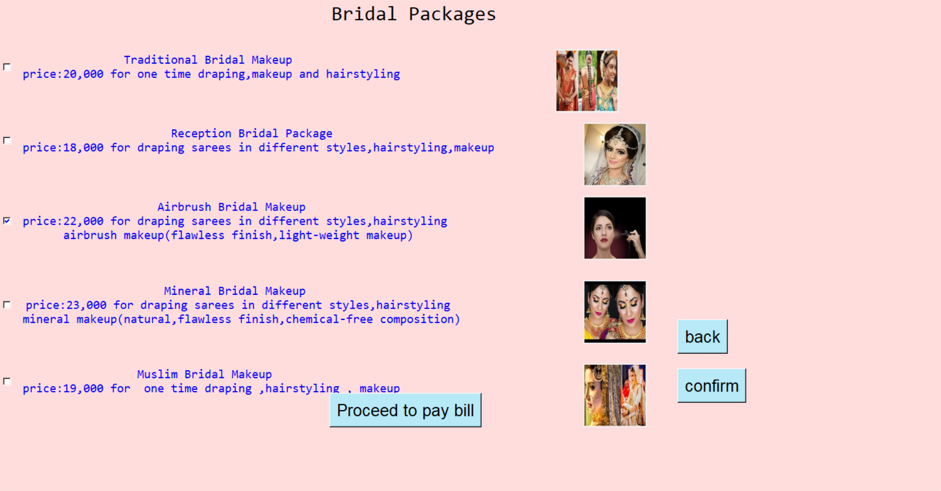

This page appears when bridal packages option is selected in the home page. It contains several

Packages for wedding makeup purpose.

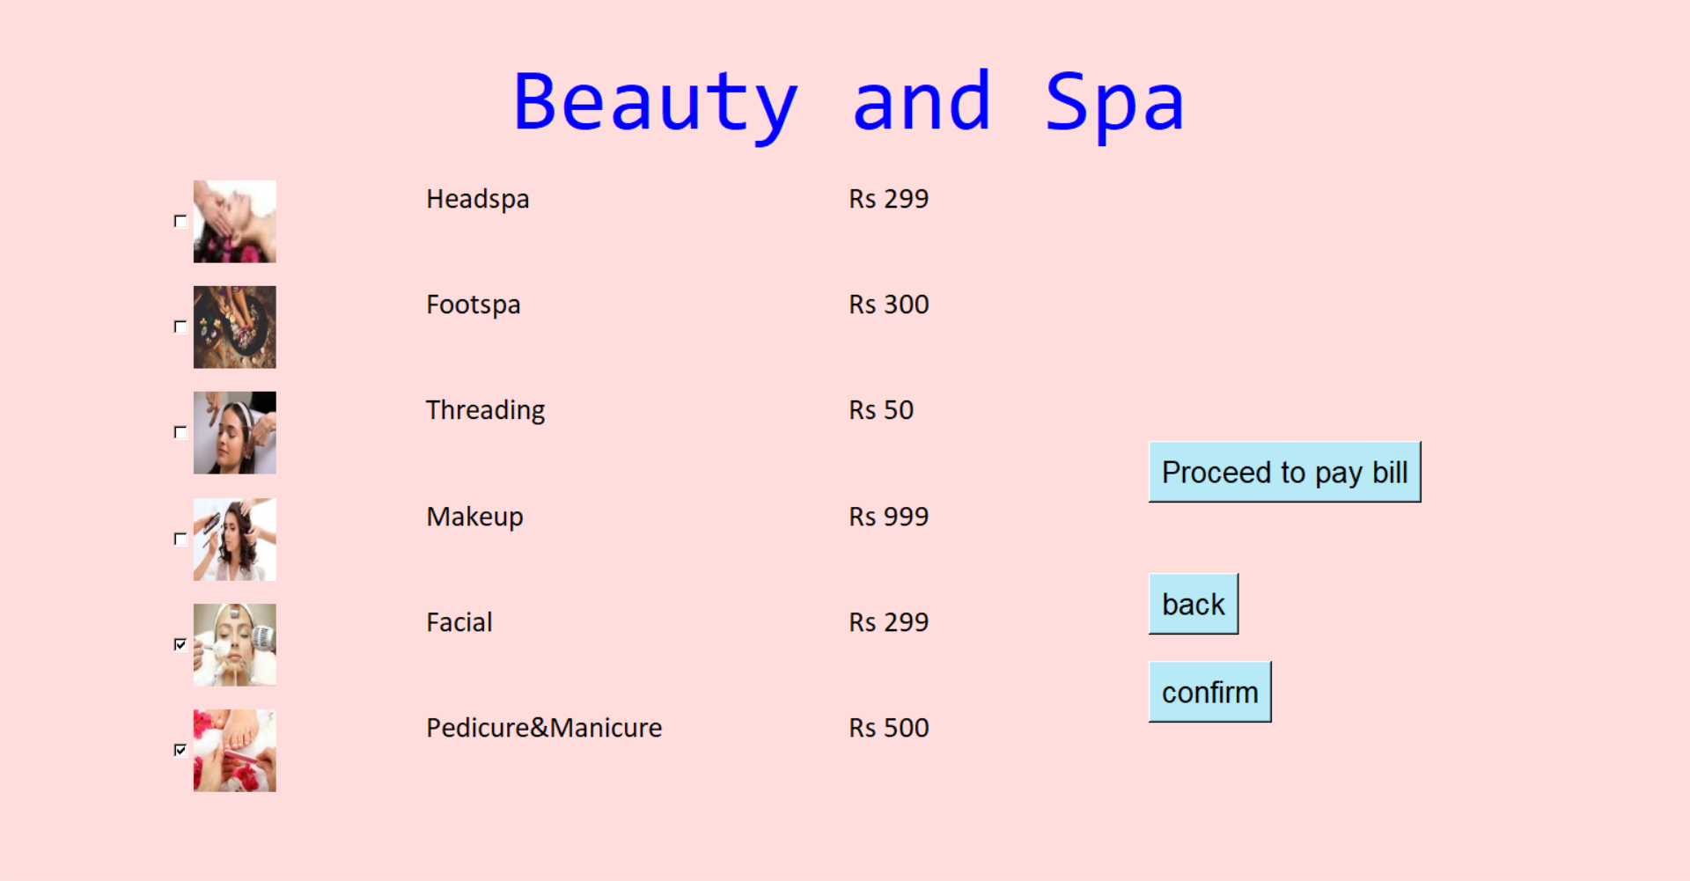

This page appears when beauty spa option is selected in the home page.

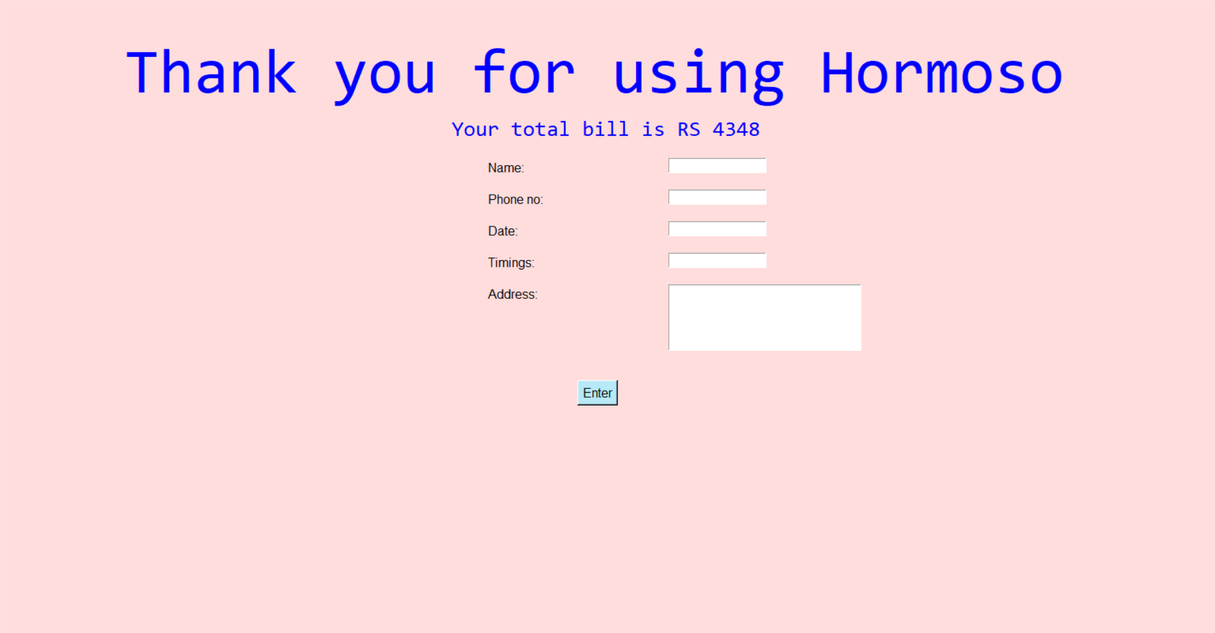

This is the final page. The details are entered here.

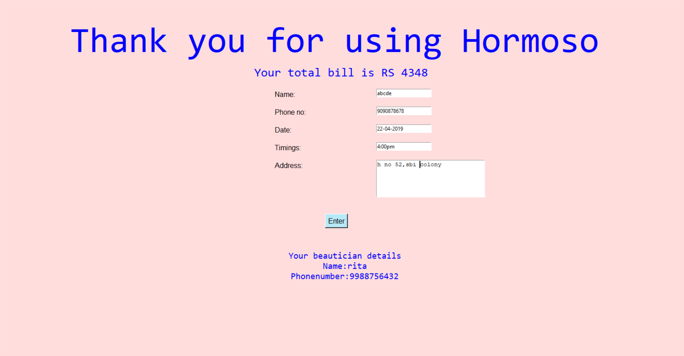

Finally, the beautician details are displayed on the window. This is the end of the program.

**Source code**

from tkinter import *

from PIL import ImageTk,Image

count=0;ti='hi';temmp=0;V=[];sums=0;BILL=[];fcount=0

def confirm():

global win3,BILL,V

for i in V:

if(i.get()!=0):

BILL.append(i.get())

def bdetails():

global f2,fd,ti,fcount

if(len(BE1.get())==0 or len(BE2.get())==0 or len(BE3.get("1.0","end-1c"))==0 or len(BE4.get())==0 or len(BE5.get())==0 or (BE5.get()).isnumeric()==False):

nl=Label(win4,text="Please enter the details properly",bg="#ffdddd",fg="black")

nl.place(relx=0.45,rely=0.55)

else:

f2=open("new.py","a+")

f2.write(BE4.get()+','+BE5.get()+','+BE1.get()+','+BE2.get()+','+BE3.get("1.0","end-1c")+','+sums+','+ti+","+'\n')

f2.close()

F=open("count.py","r+")

fcount=int(F.read())

F.seek(0)

fd=open("bdetails.py","r")

listd=fd.readlines();length=len(listd)

f=list(listd[fcount].split(','))

fcount=fcount+1

F.write(str(fcount))

dl1=Label(win4,text="Your beautician details\nName:"+f[0]+'\n'+"Phonenumber:"+f[1],font=("Consolas",15),bg="#ffdddd",fg="#0000FF")

dl1.place(relx=0.42,rely=0.7)

def back():

global win3,count

count=count+1

win3.withdraw()

def bill():

global win4,T1,count,Bill,BE1,BE2,BE3,BE4,BE5,Bu,sums,temmp,V,BILL

try:

for i in BILL:

sums=sums+i

except:

pass

sums='RS '+str(sums)

win4=Toplevel()

win4.state("zoomed")

win4.config(bg="#ffdddd")

Tl=Label(win4,text='Thank you for using Hormoso',bg='#ffdddd',fg='#0000FF',font=("Consolas",60))

Tl.place(relx=0.1,rely=0.050)

Bill=Label(win4,text="Your total bill is "+sums,bg='#ffdddd',fg='#0000FF',font=("Consolas",20))

Bill.place(relx=0.37,rely=0.18)

BE4=Entry(win4);BE5=Entry(win4)

BE1=Entry(win4);BE2=Entry(win4);BE3=Text(win4,height=5,width=30);L1=Label(win4,text='Date:',bg='#ffdddd',font=("Arial",12));L2=Label(win4,text='Timings:',bg='#ffdddd',font=("Arial",12))

L3=Label(win4,text='Address:',bg='#ffdddd',font=("Arial",12));L4=Label(win4,text='Name:',bg='#ffdddd',font=("Arial",12));L5=Label(win4,text='Phone no:',bg='#ffdddd',font=("Arial",12))

L1.place(relx=0.4,rely=0.35);L2.place(relx=0.4,rely=0.4);L3.place(relx=0.4,rely=0.45),L5.place(relx=0.4,rely=0.3);L4.place(relx=0.4,rely=0.25)

BE1.place(relx=0.55,rely=0.35);BE2.place(relx=0.55,rely=0.4);BE3.place(relx=0.55,rely=0.45);BE5.place(relx=0.55,rely=0.3);BE4.place(relx=0.55,rely=0.25)

Bu=Button(win4,text='Enter',bg='#B7E9F7',font=("Arial",12),command=bdetails)

Bu.place(relx=0.475,rely=0.6)

count=count+1

def nailart():

global x1,x2,x3,x4,x5,e1,e2,e3,e4,e5,b1,b2,b3,b4,b5,D2,D3,D4,D5,D6,pay,V,D1,F1,F2,F3,F4,F5,ti,BILL,win3,count

ti="nailart"

win3=Toplevel()

win3.state('zoomed')

win3.config(bg="#ffdddd")

Dl=Label(win3,text='Nail Art',bg='#ffdddd',fg='#0000FF',font=("Consolas",60))

Dl.place(relx=0.3,rely=0.050)

x1=ImageTk.PhotoImage(Image.open("Stensil.jpg"))

x2=ImageTk.PhotoImage(Image.open("Air brush.jpg"))

x3=ImageTk.PhotoImage(Image.open("foot.jpg"))

x4=ImageTk.PhotoImage(Image.open("simple.jpg"))

x5=ImageTk.PhotoImage(Image.open("stylish.jpg"))

e1=IntVar();e2=IntVar();e3=IntVar();e4=IntVar();e5=IntVar()

b1=Checkbutton(win3,image=x1,var=e1,onvalue=175,bg="#ffdddd")

b2=Checkbutton(win3,image=x2,var=e2,onvalue=250,bg="#ffdddd")

b3=Checkbutton(win3,image=x3,var=e3,onvalue=150,bg="#ffdddd")

b4=Checkbutton(win3,image=x4,var=e4,onvalue=200,bg="#ffdddd")

b5=Checkbutton(win3,image=x5,var=e5,onvalue=300,bg="#ffdddd")

b1.place(relx=0.1,rely=0.2);b2.place(relx=0.1,rely=0.32);b3.place(relx=0.1,rely=0.44);b4.place(relx=0.1,rely=0.56);b5.place(relx=0.1,rely=0.68)

D2=Label(win3,text='Stensil',bg='#ffdddd',fg='black',font=("Calibri",20));D3=Label(win3,text='Air brush',bg='#ffdddd',fg='black',font=("Calibri",20))

D4=Label(win3,text='Foot',bg='#ffdddd',fg='black',font=("Calibri",20));D5=Label(win3,text='Simple',bg='#ffdddd',fg='black',font=("Calibri",20))

D6=Label(win3,text='Stylish',bg='#ffdddd',fg='black',font=("Calibri",20))

D2.place(relx=0.25,rely=0.2);D3.place(relx=0.25,rely=0.32);D4.place(relx=0.25,rely=0.44);D5.place(relx=0.25,rely=0.56);D6.place(relx=0.25,rely=0.68)

F1=Label(win3,text='Rs 175',bg='#ffdddd',fg='black',font=("Calibri",20));F2=Label(win3,text='Rs 250',bg='#ffdddd',fg='black',font=("Calibri",20))

F3=Label(win3,text='Rs 150',bg='#ffdddd',fg='black',font=("Calibri",20));F4=Label(win3,text='Rs 200',bg='#ffdddd',fg='black',font=("Calibri",20))

F5=Label(win3,text='Rs 300',bg='#ffdddd',fg='black',font=("Calibri",20))

F1.place(relx=0.5,rely=0.2);F2.place(relx=0.5,rely=0.32);F3.place(relx=0.5,rely=0.44);F4.place(relx=0.5,rely=0.56);F5.place(relx=0.5,rely=0.68)

pay=Button(win3,text="Proceed to pay bill",command=bill,font=("Arial",20),bg="#B7E9F7")

pay.place(relx=0.68,rely=0.5)

V=[e1,e2,e3,e4,e5]

BB1=Button(win3,text="back",command=back,font=("Arial",20),bg="#B7E9F7")

BB1.place(relx=0.68,rely=0.65)

CB1=Button(win3,text="confirm",command=confirm,font=("Arial",20),bg="#B7E9F7")

CB1.place(relx=0.68,rely=0.75)

def bridal():

global i1,tt,i2,tt1,i3,tt2,i4,tt3,i5,tt4,i6,tt5,var,var1,var2,var3,var4,V,ti,BILL,win3,count

ti="bridal"

i2=ImageTk.PhotoImage(Image.open("bridal4.jpg"))

i3=ImageTk.PhotoImage(Image.open("UrbanClap.jpg"))

i4=ImageTk.PhotoImage(Image.open("bridal2.jpg"))

i5=ImageTk.PhotoImage(Image.open("bridal.jpg"))

i6=ImageTk.PhotoImage(Image.open("bridal3.jpg"))

var=IntVar()

var1=IntVar()

var2=IntVar()

var3=IntVar()

var4=IntVar()

win3=Toplevel()

win3.state('zoomed')

win3.config(bg='#ffdddd')

h1=Label(win3,text='Bridal Packages',bg='#ffdddd',font=('consolas',25))

h1.place(relx=0.35,rely=0)

r1=Checkbutton(win3,text=' Traditional Bridal Makeup \n price:20,000 for one time draping,makeup and hairstyling',variable=var,onvalue=20000,offvalue=0,bg='#ffdddd',fg='#0000FF',font=('consolas',15))

tt1=Label(win3,image=i2)

tt2=Label(win3,image=i3)

tt3=Label(win3,image=i4)

tt4=Label(win3,image=i5)

tt5=Label(win3,image=i6)

tt1.place(relx=0.59,rely=0.1)

tt2.place(relx=0.62,rely=0.25)

tt3.place(relx=0.62,rely=0.4)

tt4.place(relx=0.62,rely=0.57)

tt5.place(relx=0.62,rely=0.74)

r1.place(relx=0,rely=0.1)

r2=Checkbutton(win3,text='Reception Bridal Package \n price:18,000 for draping sarees in different styles,hairstyling,makeup',variable=var1,onvalue=18000,offvalue=0,bg='#ffdddd',fg='#0000FF',font=('consolas',15))

r2.place(relx=0,rely=0.25)

r3=Checkbutton(win3,text='Airbrush Bridal Makeup \n price:22,000 for draping sarees in different styles,hairstyling \n airbrush makeup(flawless finish,light-weight makeup)',variable=var2,onvalue=22000,offvalue=0,bg='#ffdddd',fg='#0000FF',font=('consolas',15))

r3.place(relx=0,rely=0.4)

r4=Checkbutton(win3,text='Mineral Bridal Makeup \n price:23,000 for draping sarees in different styles,hairstyling \n mineral makeup(natural,flawless finish,chemical-free composition)',variable=var3,onvalue=23000,offvalue=0,bg='#ffdddd',fg='#0000FF',font=('consolas',15))

r4.place(relx=0,rely=0.57)

r5=Checkbutton(win3,text='Muslim Bridal Makeup \n price:19,000 for one time draping ,hairstyling , makeup',variable=var4,onvalue=19000,offvalue=0,bg='#ffdddd',fg='#0000FF',font=('consolas',15))

r5.place(relx=0,rely=0.74)

V=[var,var1,var2,var3,var4]

pay=Button(win3,text="Proceed to pay bill",command=bill,font=("Arial",20),bg="#B7E9F7")

pay.place(relx=0.35,rely=0.8)

BB2=Button(win3,text="back",command=back,font=("Arial",20),bg="#B7E9F7")

BB2.place(relx=0.72,rely=0.65)

CB2=Button(win3,text="confirm",command=confirm,font=("Arial",20),bg="#B7E9F7")

CB2.place(relx=0.72,rely=0.75)

def haircut():

global win3,A2,kk1,kk2,kk3,kk4,kk5,zz1,zz2,zz3,zz4,zz5,ss4,ss5,ss1,ss2,ss3,AAA1,AAA3,AAA2,AAA4,AAA6,AAA5,pay,V,ti,BILL,count

ti="haircut"

win3=Toplevel()

win3.state('zoomed')

win3.config(bg="#ffdddd")

A2=Label(win3,text='Haircut',bg='#ffdddd',fg='#0000FF',font=("Consolas",60))

A2.place(relx=0.3,rely=0.050)

kk1=ImageTk.PhotoImage(Image.open("hair.jpg"))

kk2=ImageTk.PhotoImage(Image.open("hair1.jpg"))

kk3=ImageTk.PhotoImage(Image.open("hair2.jpg"))

kk4=ImageTk.PhotoImage(Image.open("hair3.jpg"))

kk5=ImageTk.PhotoImage(Image.open("hair4.jpg"))

zz1=IntVar();zz2=IntVar();zz3=IntVar();zz4=IntVar();zz5=IntVar()

ss1=Checkbutton(win3,image=kk1,var=zz1,onvalue=8000,bg="#ffdddd")

ss2=Checkbutton(win3,image=kk2,var=zz2,onvalue=850,bg="#ffdddd")

ss3=Checkbutton(win3,image=kk3,var=zz3,onvalue=400,bg="#ffdddd")

ss4=Checkbutton(win3,image=kk4,var=zz4,onvalue=10000,bg="#ffdddd")

ss5=Checkbutton(win3,image=kk5,var=zz3,onvalue=2000,bg="#ffdddd")

ss1.place(relx=0.1,rely=0.2);ss2.place(relx=0.1,rely=0.32);ss3.place(relx=0.1,rely=0.44);ss4.place(relx=0.1,rely=0.56);ss5.place(relx=0.1,rely=0.68)

AAA1=Label(win3,text='Hair Straightening',bg='#ffdddd',fg='black',font=("Calibri",20));

AAA2=Label(win3,text='Feather and Layer',bg='#ffdddd',fg='black',font=("Calibri",20));

AAA3=Label(win3,text='U cut',bg='#ffdddd',fg='black',font=("Calibri",20));

AAA4=Label(win3,text='Keratin treatment',bg='#ffdddd',fg='black',font=("Calibri",20));

AAA5=Label(win3,text='Hair spa',bg='#ffdddd',fg='black',font=("Calibri",20));

AAA1.place(relx=0.25,rely=0.2);AAA2.place(relx=0.25,rely=0.32);AAA3.place(relx=0.25,rely=0.44);AAA4.place(relx=0.25,rely=0.56);AAA5.place(relx=0.25,rely=0.68)

BBB1=Label(win3,text='Rs 8000',bg='#ffdddd',fg='black',font=("Calibri",20));

BBB2=Label(win3,text='Rs 850',bg='#ffdddd',fg='black',font=("Calibri",20));

BBB3=Label(win3,text='Rs 400',bg='#ffdddd',fg='black',font=("Calibri",20));

BBB4=Label(win3,text='Rs 10000',bg='#ffdddd',fg='black',font=("Calibri",20));

BBB5=Label(win3,text='Rs 2000',bg='#ffdddd',fg='black',font=("Calibri",20));

BBB1.place(relx=0.5,rely=0.2);BBB2.place(relx=0.5,rely=0.32);BBB3.place(relx=0.5,rely=0.44);BBB4.place(relx=0.5,rely=0.56);BBB5.place(relx=0.5,rely=0.68);

pay=Button(win3,text="Proceed to pay bill",command=bill,font=("Arial",20),bg="#B7E9F7")

pay.place(relx=0.68,rely=0.5)

V=[zz1,zz2,zz3,zz4,zz5]

CB3=Button(win3,text="confirm",command=confirm,font=("Arial",20),bg="#B7E9F7")

CB3.place(relx=0.68,rely=0.75)

BB3=Button(win3,text="back",command=back,font=("Arial",20),bg="#B7E9F7")

BB3.place(relx=0.68,rely=0.65)

def mehendi():

global win3,AA1,kl,k1,k2,k3,k4,k5,k6,z1,z2,z3,z4,z5,z6,s4,s5,s6,AA1,AA3,AA5,s1,s2,s3,AA2,AA4,AA6,pay,V,ti,BILL,count

ti="mehendi"

win3=Toplevel()

win3.state('zoomed')

win3.config(bg="#ffdddd")

AAl=Label(win3,text='Mehendi',bg='#ffdddd',fg='#0000FF',font=("Lucida",50))

AAl.place(relx=0.3,rely=0.050)

k1=ImageTk.PhotoImage(Image.open("meh2.jpg"))

k2=ImageTk.PhotoImage(Image.open("meh3.jpg"))

k3=ImageTk.PhotoImage(Image.open("meh1.jpg"))

k4=ImageTk.PhotoImage(Image.open("Foot1.jpg"))

k5=ImageTk.PhotoImage(Image.open("bangle.jpg"))

k6=ImageTk.PhotoImage(Image.open("lace.jpg"))

z1=IntVar();z2=IntVar();z3=IntVar(); z4=IntVar();z5=IntVar();z6=IntVar()

s1=Checkbutton(win3,image=k1,var=z1,onvalue=500,bg="#ffdddd")

s2=Checkbutton(win3,image=k2,var=z2,onvalue=2000,bg="#ffdddd")

s3=Checkbutton(win3,image=k3,var=z3,onvalue=400,bg="#ffdddd")

s4=Checkbutton(win3,image=k4,var=z4,onvalue=1000,bg="#ffdddd")

s5=Checkbutton(win3,image=k5,var=z5,onvalue=600,bg="#ffdddd")

s6=Checkbutton(win3,image=k6,var=z6,onvalue=550,bg="#ffdddd”)

s1.place(relx=0.1,rely=0.2);s2.place(relx=0.1,rely=0.32);s3.place(relx=0.1,rely=0.43);s4.place(relx=0.1,rely=0.55);s5.place(relx=0.1,rely=0.68);s6.place(relx=0.1,rely=0.80)

AA2=Label(win3,text='Arabic',bg='#ffdddd',fg='black',font=("Calibri",20));

AA4=Label(win3,text='Bridal',bg='#ffdddd',fg='black',font=("Calibri",20));

AA6=Label(win3,text='Simple',bg='#ffdddd',fg='black',font=("Calibri",20));

AA1=Label(win3,text='Foot Mehendi',bg='#ffdddd',fg='black',font=("Calibri",20));

AA3=Label(win3,text='Bangle',bg='#ffdddd',fg='black',font=("Calibri",20));

AA5=Label(win3,text='Lace',bg='#ffdddd',fg='black',font=("Calibri",20));

AA2.place(relx=0.25,rely=0.2);AA4.place(relx=0.25,rely=0.32);AA6.place(relx=0.25,rely=0.43);AA1.place(relx=0.25,rely=0.55);AA3.place(relx=0.25,rely=0.68);AA5.place(relx=0.25,rely=0.80)

BB1=Label(win3,text='Rs 500',bg='#ffdddd',fg='black',font=("Calibri",20));

BB3=Label(win3,text='Rs 2000',bg='#ffdddd',fg='black',font=("Calibri",20));

BB5=Label(win3,text='Rs 400',bg='#ffdddd',fg='black',font=("Calibri",20));

BB2=Label(win3,text='Rs 1000',bg='#ffdddd',fg='black',font=("Calibri",20));

BB4=Label(win3,text='Rs 600',bg='#ffdddd',fg='black',font=("Calibri",20));

BB6=Label(win3,text='Rs 550',bg='#ffdddd',fg='black',font=("Calibri",20));

BB1.place(relx=0.5,rely=0.2);BB3.place(relx=0.5,rely=0.32);BB5.place(relx=0.5,rely=0.43);BB2.place(relx=0.5,rely=0.55);BB4.place(relx=0.5,rely=0.68);BB6.place(relx=0.5,rely=0.80)

pay=Button(win3,text="Proceed to pay bill",command=bill,font=("Arial",20),bg="#B7E9F7")

pay.place(relx=0.68,rely=0.5)

V=[z1,z2,z3,z4,z5,z6]

CB4=Button(win3,text="confirm",command=confirm,font=("Arial",20),bg="#B7E9F7")

CB4.place(relx=0.68,rely=0.75)

BB4=Button(win3,text="back",command=back,font=("Arial",20),bg="#B7E9F7")

BB4.place(relx=0.68,rely=0.65)

def beautyspa():

global win3,A1,i1,i2,i3,i4,i5,i6,v1,v2,v3,v4,v5,v6,c1,c2,c3,c4,c5,c6,A2,A3,A4,A5,A6,A7,pay,V,ti,BILL,count

ti="beautyspa"

win3=Toplevel()

win3.state('zoomed')

win3.config(bg="#ffdddd")

Al=Label(win3,text='Beauty and Spa',bg='#ffdddd',fg='#0000FF',font=("Consolas",60))

Al.place(relx=0.3,rely=0.050)

i1=ImageTk.PhotoImage(Image.open("headspa.jpg"))

i2=ImageTk.PhotoImage(Image.open("footspa.jpg"))

i3=ImageTk.PhotoImage(Image.open("threading.jpg"))

i4=ImageTk.PhotoImage(Image.open("makeup.jpg"))

i5=ImageTk.PhotoImage(Image.open("facial.jpg"))

i6=ImageTk.PhotoImage(Image.open("pedicure.jpg"))

v1=IntVar();v2=IntVar();v3=IntVar();v4=IntVar();v5=IntVar();v6=IntVar()

c1=Checkbutton(win3,image=i1,var=v1,onvalue=299,bg="#ffdddd")

c2=Checkbutton(win3,image=i2,var=v2,onvalue=300,bg="#ffdddd")

c3=Checkbutton(win3,image=i3,var=v3,onvalue=50,bg="#ffdddd")

c4=Checkbutton(win3,image=i4,var=v4,onvalue=999,bg="#ffdddd")

c5=Checkbutton(win3,image=i5,var=v5,onvalue=299,bg="#ffdddd")

c6=Checkbutton(win3,image=i6,var=v6,onvalue=500,bg="#ffdddd")

c1.place(relx=0.1,rely=0.2);c2.place(relx=0.1,rely=0.32);c3.place(relx=0.1,rely=0.44);c4.place(relx=0.1,rely=0.56);c5.place(relx=0.1,rely=0.68);c6.place(relx=0.1,rely=0.8)

A2=Label(win3,text='Headspa',bg='#ffdddd',fg='black',font=("Calibri",20));A3=Label(win3,text='Footspa',bg='#ffdddd',fg='black',font=("Calibri",20))

A4=Label(win3,text='Threading',bg='#ffdddd',fg='black',font=("Calibri",20));A5=Label(win3,text='Makeup',bg='#ffdddd',fg='black',font=("Calibri",20))

A6=Label(win3,text='Facial',bg='#ffdddd',fg='black',font=("Calibri",20));A7=Label(win3,text='Pedicure&Manicure',bg='#ffdddd',fg='black',font=("Calibri",20))

A2.place(relx=0.25,rely=0.2);A3.place(relx=0.25,rely=0.32);A4.place(relx=0.25,rely=0.44);A5.place(relx=0.25,rely=0.56);A6.place(relx=0.25,rely=0.68);A7.place(relx=0.25,rely=0.8)

B1=Label(win3,text='Rs 299',bg='#ffdddd',fg='black',font=("Calibri",20));B2=Label(win3,text='Rs 300',bg='#ffdddd',fg='black',font=("Calibri",20))

B3=Label(win3,text='Rs 50',bg='#ffdddd',fg='black',font=("Calibri",20));B4=Label(win3,text='Rs 999',bg='#ffdddd',fg='black',font=("Calibri",20))

B5=Label(win3,text='Rs 299',bg='#ffdddd',fg='black',font=("Calibri",20));B6=Label(win3,text='Rs 500',bg='#ffdddd',fg='black',font=("Calibri",20))

B1.place(relx=0.5,rely=0.2);B2.place(relx=0.5,rely=0.32);B3.place(relx=0.5,rely=0.44);B4.place(relx=0.5,rely=0.56);B5.place(relx=0.5,rely=0.68);B6.place(relx=0.5,rely=0.8)

pay=Button(win3,text="Proceed to pay bill",command=bill,font=("Arial",20),bg="#B7E9F7")

pay.place(relx=0.68,rely=0.5)

V=[v1,v2,v3,v4,v5,v6]

CB5=Button(win3,text="confirm",command=confirm,font=("Arial",20),bg="#B7E9F7")

CB5.place(relx=0.68,rely=0.75)

BB5=Button(win3,text="back",command=back,font=("Arial",20),bg="#B7E9F7")

BB5.place(relx=0.68,rely=0.65)

def hm():

global ll1,bb1,win2,ll2,ll3,ll4,bb2,bb3,bb4,ll5,bb5

ll1=ImageTk.PhotoImage(Image.open("g6.jpg"))

ll2=ImageTk.PhotoImage(Image.open("g9.jpg"))

ll3=ImageTk.PhotoImage(Image.open("g7.jpg"))

ll4=ImageTk.PhotoImage(Image.open("bride1.jpeg"))

ll5=ImageTk.PhotoImage(Image.open("g5.jpg"))

bb1=Button(win2,image=ll1,command=nailart)

bb2=Button(win2,image=ll2,command=mehendi)

bb3=Button(win2,image=ll3,command=haircut)

bb4=Button(win2,image=ll4,command=bridal)

bb5=Button(win2,image=ll5,command=beautyspa)

bb1.place(relx=0,rely=0.6)

bb2.place(relx=0.2,rely=0.6)

bb3.place(relx=0.4,rely=0.6)

bb4.place(relx=0.6,rely=0.6)

bb5.place(relx=0.8,rely=0.6)

def ss():

global kk,c,l4,l5,l6,l7,l8,win2

if(c==5):

c=0

kk[4].place_forget()

kk[0].place(relx=0.30,rely=0)

else:

kk[c-1].place_forget()

kk[c].place(relx=0.30,rely=0)

c=c+1

win2.after(2000,ss)

def ssi():

global l4,l5,l6,l7,l8,t1,t2,t3,t4,t5,win2,c,kk

l4=ImageTk.PhotoImage(Image.open("briidaloff.jpg"))

l5=ImageTk.PhotoImage(Image.open("offer.png"))

l6=ImageTk.PhotoImage(Image.open("facialr.jpg"))

l7=ImageTk.PhotoImage(Image.open("nailartoff.jpg"))

l8=ImageTk.PhotoImage(Image.open("haircutoff.jpg"))

t1=Label(win2,image=l8)

t2=Label(win2,image=l5)

t3=Label(win2,image=l6)

t4=Label(win2,image=l4)

t5=Label(win2,image=l7)

kk=[t1,t2,t3,t4,t5]

c=1

t1.place(relx=0.30,rely=0)

win2.after(2000,ss)

def usc():

global win2

f=open('details.py','r')

i=len(f.readlines())

f.seek(0)

for t in range(0,i+1):

k=list(f.readline().split(','))

if(k[0]==e1.get() and k[1]==e2.get()):

break

f.close()

if(t==i):

l3=Label(text='invalid password or user name')

l3.place(relx=0.43,rely=0.85)

else:

win2=Toplevel()

win2.config(bg='#ffdddd')

win2.state('zoomed')

win2.after(1,hm)

win2.after(1,ssi)

def lsc():

global win2,nl

if(len(e3.get())==0 or len(e4.get())==0 or len(e5.get())==0 or (e5.get()).isnumeric()==False):

nl=Label(win1,text="Please enter the details properly")

nl.place(relx=0.43,rely=0.85)

else:

f=open('details.py','a')

f.write(e3.get()+','+e4.get()+','+e5.get()+'\n')

win2=Toplevel()

win2.config(bg='#ffdddd')

win2.state('zoomed')

win2.after(10,hm)

win2.after(500,ssi)

def sign_in():

global e3,e4,e5

name=Label(text='NAME',font=('Courier',10),bg='#B7E9F7')

name.place(relx=0.38,rely=0.68)

pw=Label(text='PASSWORD',font=('Courier',10),bg='#B7E9F7')

pw.place(relx=0.38,rely=0.73)

e3=Entry()

e3.place(relx=0.58,rely=0.68)

e4=Entry(show='*')

e4.place(relx=0.58,rely=0.73)

pno=Label(text='PHONE NUMBER',font=('Courier',10),bg='#B7E9F7')

pno.place(relx=0.38,rely=0.78)

e5=Entry()

e5.place(relx=0.58,rely=0.78)

b4=Button(text='enter',command=lsc,bg='#B7E9F7')

b4.place(relx=0.58,rely=0.83)

def log_in():

global e1,e2,b3,l2

name=Label(text='NAME',font=('Courier',10),bg='#B7E9F7')

name.place(relx=0.38,rely=0.68)

pw=Label(text='PASSWORD',font=('Courier',10),bg='#B7E9F7')

pw.place(relx=0.38,rely=0.73)

e1=Entry()

e1.place(relx=0.58,rely=0.68)

e2=Entry(show='*')

e2.place(relx=0.58,rely=0.73)

b3=Button(text='enter',command=usc,bg='#B7E9F7')

b3.place(relx=0.58,rely=0.83)

def f1():

global l1,win1,b1,b2,p2

l1.destroy()

p2=ImageTk.PhotoImage(Image.open('welcomepage.png'))

l2=Label(image=p2)

l2.grid()

b1=Button(text='sign up',height=2,width=15,bg='#B7E9F7',command=sign_in)

b2=Button(text='log in',height=2,width=15,command=log_in,bg='#B7E9F7')

b1.place(relx=0.38,rely=0.60)

b2.place(relx=0.58,rely=0.60)

win1=Tk()

win1.state('zoomed')

p1=ImageTk.PhotoImage(Image.open('hermoso.png'))

l1=Label(image=p1)

l1.grid()

win1.after(8000,f1)

win1.config(bg='#ffdddd')

win1.mainloop()

**Conclusion:**

This application helps customers in providing a good quality services in field of cosmetology . This application main mission is to provide customer service at their place which is feasible and helps in time management.

The following features may be added in future :

This can be developed as a full time application using Data bases.

More services can be added .